**Khyber Pakhtunkhwa Human Capital Investment Project (KPHCIP)**

**Health Department**

**Indigenous People Plan**

**BHU Bumburet**

**August 2023**

**Prepared by**

**Social Safeguards Team of Project Management Unit – Khyber Pakhtunkhwa Human Capital Investment Project (PMU-KPHCIP Health)**

**ABBREVIATIONS**

AKRSP – Agha Khan Rural Support Program

AVDP – Ayun and Valleys Development Program

BHU – Basic Health Unit

CEMP – Contractor Environment Management Plan

DHO – District Health Officer

DHQ – District Head Quarter

EMP – Environment Management Plan

FGDs – Focus Group Discussions

GAC – Global Affairs Canada

GRM – Grievance Redress Mechanism

HRH – Human Resource for Health

IPP – Indigenous People Plan

IPs – Indigenous People

KIIs – Key Informant Interviews

LHVs – Lady Health Visitors

LHW – Lady Health Worker

NGO – Non-Governmental Organization

KPHCIP – Khyber Pakhtunkhwa Human Capital Investment Project

OP – Operational Policy

PDO – Project Development Objective

PMU – Project Management Unit

RHC – Rural Health Centre

SIF – Secours Islamique France

SRSP – Sarhad Rural Support Program

TMA – Tehsil Municipal Administration

UC – Union Council

VC – Village Councilor

WB – World Bank

**Table of Contents**

**1.** **Introduction and Context** 1

**2.** **Project Description** 1

2.1. Project Overview 1

2.2. Project Development Objectives 1

2.3. Project Duration 1

2.4. Project Target Districts 2

**3.** **Sub-project Description** 2

**4.** **WB Policy on Indigenous Peoples (OP 4.10)** 3

**5.** **Baseline Socio-economic/ Cultural Information** 3

**6.** **Indigenous Peoples Plan (IPP)** 5

**7.** **Stakeholder Consultations** 6

7.1. Methodology 6

7.2. Objectives of Stakeholder Consultation on Rehabilitation Activities 6

7.3. Sub-Project Stakeholders 7

7.4. Detail of Consultation Meetings 7

**8.** **Key Concerns Raised by the Participants during FGDs Sessions** 9

**9.** **Implementation Arrangements** 10

**10.** **Engagement Plan** 11

**11.** **Grievance Redress Mechanism** 12

11.1. Scope of GRM 12

11.2. Proposed Procedure for Registering Grievance and its Redressal 12

11.3. GRM Structure 13

**12.** **Information Disclosure** 14

**13.** **Cost of IPP Implementation** 15

**Figure 1.** GRM Structure with Multiple Levels 14

**List of Tables**

Table 1. Sub-Project Stakeholders 7

Table 2. Detail of Consultations and Key Information Interviews Conducted 7

Table 3. Concerns of FGDs’ participants and Responses 9

Table 4: Engagement Plan 11

Table 5: Budget for IPP Implementation 15

**Annexures**

Annexure 1: Summaries of Stakeholder Consultations/ Focus Group Discussions 16

Annexure 2: List of Participants 21

Annexure 3: Pictorial View of the Consultation Meetings/ FGDs Conducted 32

Annexure 4: Questionnaire (English Version) 39

Annexure 5: Questionnaire (Urdu Version) 41

Annexure 6: Detail of Flood Affected Healthcare Facilities 43

# **Introduction and Context**

This IPP document prepared is to consult with the Kalash people on the intended rehabilitation for the flood affected health facility that has been damaged by floods in an area inhabited by the kalash people. The location is in the vicinity of Bumburet in Kalash Valley, which is in the Lower Chitral district. The IPP aims to address impacts of the rehabilitation work while ensuring that the rights and needs of the local indigenous communities are respected. The plan outlines mitigation measures either to avoid or to minimize any negative effects on the Kalasha community in Bumburet valley, including consultations with local stakeholders and the implementation of culturally sensitive solutions. According to United Nation High Commissioner for Refugees the Kalash is the most recognized as indigenous peoples (IPs) in Pakistan. Likewise, under the World Bank Operation Policy 4.10, Kalash is acknowledged as indigenous peoples. The WB OP 4.10 assures that the development process completely respects Indigenous Peoples' dignity, human rights, economies, and traditions. The Bank requires the borrower to engage in a process of free, prior, and informed consultation for all projects proposed for Bank financing that affect indigenous peoples, resulting in wide community support for the project by the affected indigenous peoples. It also ensures measures to avoid, minimize, mitigate, or compensate for any adverse effects arising from the project or sub-projects. Its goal is to provide possibilities for IPs to benefit from sustainable development in a way that is inclusive, accessible, and sensitive to cultural differences.

This Indigenous People Plan (IPP) is based on consultations and field data collection from various stakeholders including community members living around the floods damaged health facility (BHU) proposed for rehabilitation under the flood response activities at Bumburet, lower Chitral. The measures presented here include actions that must be carried out and tracked while the project is being conducted, and they are incorporated into the project design and monitoring. The report further provides a brief introduction of the project, sub-project description, Wb Policy on IPs (OP 4.10) and sub-detail of consultations and data collection. The IPP attempts to report on every activity/ initiative and progress undertaken during stakeholder consultations process.

# **Project Description**

## **Project Overview**

The Government of Khyber Pakhtunkhwa (GoKP) is implementing the KP Human Capital Investment Project (KPHCIP) with support from the World Bank (WB). The project aims to improve utilization of quality health and education services in selected refugee hosting districts of KP including support to deal with the COVID-19 pandemic. The project aims to achieve this by directly investing to fill supply and demand gaps and strengthening service delivery systems through improved management and governance.

## **Project Development Objectives**

The proposed Project Development Objective (PDO) is to improve availability, utilization and quality of primary healthcare services and elementary education services in selected districts of Khyber Pakhtunkhwa.

## **Project Duration**

The Project is expected to be implemented over a five-year period from FY 2021 through FY 2025.

## **Project Target Districts**

The project selected the original districts Peshawar, Nowshera, Haripur and Swabi. These districts have been selected based on refugee population size and funding available from the provincial Annual Development Plan or developmental partners. In terms of flood response, the heath component will be responded to additional sixteen flood affected districts, which are Dir lower, Dir upper, Charsadda, Abbottabad, Lakki, DI khan, Upper Chitral, Swat, Tank, Chitral Lower, Karak, Kohistan Lower, Kohistan Upper, Kolai Palas (Kohistan), Khurram Upper and Shangla.

# **Sub-project Description**

Health and Education are one of the most vulnerable sectors during emergencies. Floods hit the whole country in general and Khyber Pakhtunkhwa province during August 2022. Many healthcare facilities and schools were either partially or completely damaged with substantial losses to infrastructure. KP-HCIP in view of flood response anticipates supporting the Khyber Pakhtunkhwa Government in the renovation, reconstruction and rehabilitation of damaged health facilities and schools.

The devastating floods have affected 17 districts of Khyber Pakhtunkhwa. As per preliminary assessments, about 15 health facilities have been washed away while 143 healthcare facilities have been partially damaged by the calamity. However, the destruction presents a good opportunity for developing a more rationalized health care delivery system in the affected area based on essential package of health services, integration of small units, making user friendly health outlets and flood resistant foundations for new infrastructure especially in flood zone areas. The list of damaged health facilities is provided as Annex 6.

Unfortunately, among the damaged health care facilities in other KP districts, BHU - Bumburet in Kalash area was partially damaged due to the recent floods. In view of extent of damages, the back wall of the BHU-Bumburet got major cracks which apparently further made vulnerable the entire BHU building in case of any minor or severe level flood waters in future. This healthcare facility falls at the main natural passageway of flash floods water coming from adjacently located mountains at upstream. The damaged back wall of BHU appears to require minor rehabilitation work, which is estimated to take approximately 10 to 15 days to complete the rehabilitation of the wall. This also signifies that the minor rehabilitation work will not pose significant adverse impacts on the BHU operations. Although the extent of damage is very little, a solid retaining/protection wall for future flash flood is indispensable. The local surrounding communities including Indigenous Peoples of Kalash residing in Bumburet also depend on this BHU for seeking medical treatment. In view of the flood response support to the KP government in reconstruction or rehabilitation of damaged health facilities, the Health Project Management Unit (PMU HCIP) intends to rehabilitate the BHU located in the Bumburet area, in Kalash which is inhabited by indigenous people. This will ensure that it meets the necessary standards and requirements for delivering healthcare services to the local community including the Kalash community.

**View of Damaged back wall of BHU**

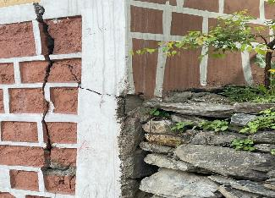

The BHU Bumburet was established for the first time in 1966. Its total covered area is 75 Marla or 3.15 Kanal or 20418.8 Square feet. There are a total of 11 staff members, (07 males and 04 females). The staff is comprised of 01 Medical Officer (post is vacant for the last 6 months), 01 medical technician and 01 Disperser (male), 01 EPI (male), 02 Ward-boy (male) and 01 LHV, 03 Mid-wives and 1 Sweeper. The BHU main building contains; (i) four rooms (ii) minor OT (overseeing room) (iii) waiting area (iv) two toilets (male & female) (v) 04 paramedics quarters (vi) 2 class-four’s quarters (vii) 01 Medical Officer – Bangalow (viii) 01 paramedics quarter is serving as Labor-Room (ix) a LHW program office and (x) medicines store. The mentioned rooms remained safe during the flood while only the back wall of the BHU was damaged due to flood.

**Another view of major cracks in back wall of BHU**

# **WB Policy on Indigenous Peoples (OP 4.10)**

The World Bank Operational Policy 4.10 ensures that the development process fully respects the dignity, human rights, economies, and cultures of Indigenous Peoples. For all projects that are proposed for Bank financing and affect indigenous peoples, the Bank requires the borrower to engage in a process of free, prior, and informed consultation, resulting in broad community support to the project by the affected indigenous peoples. All such Bank-financed projects must include measures to:

1. Screening by the Bank to identify whether Indigenous Peoples are present in, or have collective attachment to, the project area.
2. A social assessment by the borrower.
3. A process of free, prior, and informed consultation with the affected Indigenous Peoples’ communities at each stage of the project, and particularly during project preparation, to fully identify their views and ascertain their broad community support for the project.
4. The preparation of an Indigenous Peoples Plan or an Indigenous Peoples Planning Framework; and
5. Disclosure of the draft Indigenous Peoples Plan or draft Indigenous People Planning Framework.

Following WB approval, this plan will be made public on the website and in the local community.

# **Baseline Socio-economic/ Cultural Information**

According to the 2017 census report Ayun UC has 27 villages with a total population of 28,182 individuals and 3,983 households with an average household size of 7.07. Kalash’s population lives in 15 villages of Ayun UC with total population of 4,100 (2013), which is 14.5% of Ayun’s total population.

Kalash Valley is situated in the district of Chitral in northwest Pakistan and is home to over 4,100 people known as Kafirs or Kalashi. They are distinguished by their culture, language, and religion and are well-known to anthropologists and linguists worldwide. These community groups are currently located in the Bumburet, Rumbur, and Birir valleys of the Ayun Union Council (UC) in Lower Chitral, while some also live in Chitral and other Pakistani cities for work and educational purposes. The topography of the area is varied, with 28.5% of the region covered in glaciers, snow-clad mountains, bare rock, and barren ground, and 62% of the land supporting only pasture with sparse vegetation.

Chitral has a dry Mediterranean climate with almost no rainfall during summers. In the winter the night- time temperature occasionally drops to −10 0C. Winter snowfall in the town can be quite heavy with an accumulation of up to two feet being quite common, at higher elevations snowfall can reach as high as 20 meters (70 ft). The weather is very cold during the winter. Kalash is a remote settlement with little contact with people and institutions outside of its immediate surroundings, although this is changing because of the inflow of tourists. They are religiously and culturally connected to their ancestral lands (including communal lands). They use their property for agriculture and animal grazing. A portion of their land is set aside for traditional graveyards.

As per the Ayun Village Development Program representative, the CEO of Ishpata News Network, and the former Minister for Minorities Affairs, 7 to 9 villages rely on BHU-Bumburet for healthcare services. The total population of Bumburet is 8741, comprising 1197 households. Among these households, there are 245 consisting of 1795 Kalasha individuals, with an average household size of 7.7 persons, as per the household survey conducted by Ishpata News Network and AVDP in September 2022.

Kalash, like many other languages in the southern Himalaya, is a Dardic language. Many Kalash speakers are familiar with Khowar, another Dardic language used in the region for interethnic contact, as well as Urdu, Pakistan's official language.

Many Kalash children attend primary schools, and others go on to high schools and universities for access to education. Currently, in Bumburet valley the available schools’ facilities are GGPS Payeen 01, GPS 06 and GKPS 02, private schools 03 and boys’ middle school 01, GHS boys 01, GGHS 01 and a private college 01. Over 90% of Kalash youngsters attend local government schools, and many also move to Chitral for higher education. Children in Kalash are educated in the Kalashi language to better understand their religion and culture. Mostly the government-run schools are accessible in the region for secondary education; they do not educate in the Kalashi language or about Kalash religion and culture and have mandated Islamic studies as part of their curriculum.

Women perform all but the most laborious agricultural and forest tasks whereas men are associated with tasks such a herding, cheese making, milking, etc. Overall, the Kalash is a patriarchal society, with strong male dominance in financial, political, and cultural areas. Usually, the men control the household finances and take major family decisions. On the other hand, women take up the bulk of the economic activity - primarily working in the fields, some women run their own shops as well selling items to the tourists and undertake domestic activities such as rearing children, collecting water, cooking, and washing etc.

The residents of Bumburet largely depend upon livestock and agriculture. Some Kalash people have small enterprises including hotels and shops on main Bumburet road and some are employees in the hotels. The people associated with small businesses mainly depend on tourists.

The Kalash economy is based on forest, products from fruit trees and agriculture which is mostly women's work, and seasonal movement of livestock animal husbandry. The crops grown are maize, wheat, and beans on small, irrigated fields. Fruits and nuts, such as walnuts, grapes, apples, pears, apricots, mulberry, are also grown in Bumburet and Rumbur Valleys. Together with mushrooms gathered in the forests, they are sold outside the communities for cash income. Goats are the main animals herded; they are considered as a gift of the gods.

Kalashi festivals are famous in the world. Kalash celebrates many festivals throughout the year, during which they perform colorful dances. For six days, traditional local music events and feasts are held continually. The following festivals are held in Kalash Valley throughout the year such as (i) Chilim Jusht, (ii) Utchal, (iii) Phoo and (iv) Chaumos.

Regarding a complaint system,, every village in the Kalasha valley has its own Qazi (traditional/religious leaders whose jurisdictions cover several villages; communities follow their own traditional social hierarchies) both male and female sides. He is also serving as a permanent member of the Jirga (a traditional assembly of leaders that make decisions by consensus and according to the local customs/ traditions) to resolve any conflict among the community members. These Qazi`s are responsible for announcing the date for every festival, dispute resolution and ensure that the community adheres to abiding by the local traditions. They also teach and preach youth rituals, offerings, and sacrifices.

Qazi in Kalash acquires the same status as the Imam and Ulema in Islam and Pope and Priest in Christianity. He is known as the religious preacher who guides the norms of the traditional culture. He is a respectable member of society who a well-informed, wise, and honest man. The one who remembers most of the stories regarding the Kalasha heritage is selected for the post. During the consultations process, the two female focal persons namely Miss. Iran Bibi and Shaira Bibi were interviewed as key informant and local focal persons. These two female focal persons were well known to the Bumburet communities as they are serving as female Qazis and nominated as Village Councilors and representing their respective Kalasha communities/ villages. Additionally, another two female LHVs from kalasha working in the same BHU Bumburet were also interviewed during consultation with PCMC members at the healthcare facility.

There are several local and international NGOs operating in the Ayun union council, including the Bumburet villages, with various interventions. Currently, a local NGO called Ayun Valleys Development Programme AVDP, with financial support from Agha Khan Rural Support Program (AKRSP) and Global Affairs Canada (GAC), is working in Bumburet. Their project includes organizing events on cultural diversity, conducting sessions on mental health awareness, establishing community-based saving groups (exclusively for females), and providing sports kits to the government girls’ higher secondary school in Bumburet.

Another local organization, Ishpata News, is functioning as an NGO and is currently conducting socio-economic surveys in the Kalasha communities. This initiative is funded by the United States Institute of Peace (USIP). Sarhad Rural Support Program (SRSP), a well-known local organization, is focused on child protection activities, particularly in the flood-affected areas within the Ayun union council, including the Kalasha communities in Bumburet.

Additionally, an international NGO called Secours Islamique France (SIF) is operating in the Bumburet area, with interventions in cash-for-work and cash-for-food activities.

# **Indigenous Peoples Plan (IPP)**

An Indigenous Peoples Plan is required for the sub-project rehabilitation of the flood-damaged BHU-Bumburet in the Kalash valley. This IPP is being developed in accordance with WB OP 4.10, which is for indigenous people. Therefore, in view of flood emergency response, the WB policy WB policy on Indigenous People OP 4.10 triggered therefore, this IPP is to be prepared due to presence of flood damaged health care facility in Kalash/Bumburet Valley of Chitral Lower.

Input received at community consultations/ Focus Group Discussions (FGDs) and from Key Informant Interviews (KIIs) held from May 5th – 7th 2023 for rehabilitation of BHU-Bumburet.

# **Stakeholder Consultations**

In the process of preparing this IPP, individual as Key Informant Interviews (KIIs), and focus group discussions were held with the Kalasha people both male and female residing either adjacent to or around the BHU-Bumburet and officials of concerned departments. The latter included members of the Primary Healthcare Management Committee (PCMC) at BHU and officials of District Health Office (DHO) office, MS DHQ Hospital Chitral, local administration, and village councilors. Local social activists, and local organization/ NGOs such as Ayun Valleys Development Programme (AVDP), Ishpata News and Welfare Organization working in or for indigenous people were also interviewed. These meetings were held from May 5th to 7th 2023. A total of 7 FGDs/ consultation meetings and 9 KIIs were held with the local communities including both Kalasha and Muslim Sheikh people in which a total of 98 persons participated, of whom 52 were men and 46 were women.. Separate meetings were held with the women keeping in view the local traditions so that the women could freely express their opinions and concerns regarding the planned rehabilitation work. The list of participants of the consultation meetings both with male and female and the details of FGDs and KIIs are provided as Annex 3 respectively.

## **Methodology**

In the process of preparing this indigenous people plan, individual as KIIs, and focus group discussions were held with the Kalasha people, living either adjacent to or around or dependent on the BHU-Bumburet, including both male, female of Kalasha and Muslim Sheikh communities and other stakeholders including officials of concerned departments especially with the DHO and MS DHQ Hospital Lower Chitral and members of Primary Health Care Committee (PCMC) at BHU, officials of tehsil municipal administration (TMA), Officials of District Health Office (DHO), representatives of local organization working such as AVDP, Ishpata News & development organization in the Kalasha communities were held. A total of 7 group meetings and 9 key informant interviews (KIIs) were conducted in which a total of 98 individuals including 52 male and 46 female participated. Separate sessions with the Kalasha as well as Muslim Sheikh community women were organized in accordance with local customs, allowing the ladies to freely express their ideas/opinions and concerns about the planned rehabilitation activities in BHU. A summary of the consultations has been provided in Table 2.

A questionnaire was developed in English, along with a translated version in Urdu (attached as Annex 4 and 5, respectively). Prior to the formal consultation process, the questionnaire underwent pretesting to establish its flow and sequence. Based on the results of the pretesting exercise, the questions were rearranged accordingly.

The Kalasha people who were consulted, both male and female, were proficient in speaking and understanding Urdu language. However, in cases where translation was required, a local social activist from a local organization was engaged to help as translator during consultation meetings. He helped translate the questions asked in the locally prevalent Kalasha language.

## **Objectives of Stakeholder Consultation on Rehabilitation Activities**

Consultation meetings held with the resident communities adjacent to or around the BHU-Bumburet/ Kandisar as well as with other relevant stakeholders to:

* Collect general stakeholder’s view/ feedback particularly of the Kalasha people about the planned rehabilitation work.
* Record any suggestions they may have and any concerns they may wish to put in record, and
* Address their concerns by adopting suitable mitigation measures during the planned rehabilitation work.

## **Sub-Project Stakeholders**

The stakeholders identified for sub-project rehabilitation activities are the Kalasha and other people (both male & female) either living adjacent to or around and dependent on the flood damaged healthcare facility BHU-Bumburet. Other stakeholders identified included private organizations, local social activists, and public representatives such as officials of DHO office, officials of tehsil municipal administration.

The sub-project rehabilitation related consultations were held at different locations, around the BHU-Bumburet, were attended particularly by the Kalasha people and other available community members including Muslims. Following Table 1 depicts the stakeholders of the sub-project:

Table 1. Sub-Project Stakeholders

|  |  |
| --- | --- |
| **Category** | **Stakeholders** |
| Affected Parties (primary stakeholders) | * Para medical staff and PCMC members of the flood affected BHU. * Local Community and people living around the damaged BHU-Bumburet including women and Muslim communities or any religious minorities. |
| * District Health Department Chitral (District Health Officials) |
| Other Interested Parties | * MS DHQ Hospital Chitral. * NGOs working in Bumburet for Kalasha people. * Local social activists. * Any local community organizations/ village development organizations working in/for the conservation and promotion of Kalasha people such as Ayun & Valleys Development Program (AVDP) etc. * Official of local Government (Village and Neighborhood Councilors) * Officials of Local Administration (TMA). * Health Specialists of Kalash Valley. |

## **Detail of Consultation Meetings**

The consultation meetings of rehabilitation activities in BHU-Bumburet in Kalasha area were conducted during May 5th – 7th 2023, as listed in Table 2.

Table 2. Detail of Consultations and Key Information Interviews Conducted

|  |  |  |  |  |  |
| --- | --- | --- | --- | --- | --- |
| **S.#** | **Date** | **Venue** | **No. of Participants** | | **Remarks** |
| **Male** | **Female** |
| 1 | May 5th, 23 | BHU-Bumburet/Kandisar | 13 | 2 | Meeting with PCMC members, available BHU staff (two female LHVs from kalasha working in the same BHU) and village Kandisar community members |
| 2 | May 5th, 23 | Shahzada Khan Chowk/ Betak in village Krakaal | **--** | **7** | Meeting female Kalasha community members in village Krakaal |
| 3 | May 5th, 23 | Abdul Haleem Chowk/ Betak in village Krakaal | 6 | **--** | Meeting male Kalasha community members in village Krakaal |
| 4 | May 7th, 23 | Ghulam Noor Chowk/ Betak in village Sheikhan-dey | 14 | **--** | Meeting male Muslim Sheikh community members in village Sheikhan-dey |
| 5 | May 6th, 23 | Ghulam Noor Chowk/ Betak in village Sheikhan-dey | -- | 8 | Meeting female Muslim Sheikh community members in village Sheikhan-dey |
| 6 | May 6th, 23 | At the lawn of Ishpata News Office in village Anish | -- | 27 | Meeting female Kalasha community members of village Anish & Baron village participated) |
| 7 | May 6th, 23 | At the lawn of Ishpata News Office in village Anish | 10 | -- | Meeting male Kalasha community members both of village Anish and Baron village participated) |
| **Key Informant Interviews (KIIs)** | | | | | |
| 8 | May 3rd, 23 | Serena Hotel Peshawar | 1 |  | KII with Mr. Wazir Zada, Ex-Minister for Minorities’ Affairs. Also belong to Kalasha community |
| 9 | May 5th, 23 | BHU Bumburet | 1 |  | KII with Mr. M Javed, Manager in AVDP program and a local social activist. |
| 10 | May 5th, 23 | MS DHQ Hospital Chitral Lower | 1 |  | KII with Mr. Shahzada Haider ul Mulk as service provider in case of serious health issue to Kalasha community |
| 11 | May 7th, 23 | Office of DHO Chitral Lower | 2 |  | KII with Dr. Fayaz Ali Loomi, District Health Officer, Chitral Lower |
| 12 | May 7th, 23 | Ghulam Noor Betak/ Chowk, village Sheikhan-dey | 1 |  | KII with Mr. Khalil Ur Rehman, Chairman Village Council (Muslim Sheikh) |
| 13 | May 7th, 23 | Office of Ishpata News Network (Pvt) in village Anish | 1 |  | KII with Mr. Luq Rehmat, Village Councilor (Anish) & also CEO of Ishpata News Network (Pvt) |
| 14 | May 7th, 23 | Office of TMA located in village Anish-Bumburet | 2 |  | KII with Mr. M Hanif & Mr. Sikandar Shah, TMO & Area field Supervisor respectively |
| 15 | May 7th, 23 | At her house in village Anish-Bumburet |  | 1 | KII with Miss. Shaira Bibi, female village councilor also belongs to Kalasha community of village Anish & Baron – Bumburet |
| 16 | May 7th, 23 | At her house in village Anish-Bumburet |  | 1 | KII with Miss. Iran Bibi, a local social activist (also of village Anish/ Baron – Bumburet |
| **Total** | | | **52** | **46** |  |

# **Key Concerns Raised by the Participants during FGDs Sessions**

The main concerns raised by the participants during the FGDs/ consultation sessions, particularly during and after the rehabilitation work in the BHU Bumburet are summarized in **Table 3.**

Table 3. Concerns of FGDs’ participants and Responses

|  |  |  |  |
| --- | --- | --- | --- |
| **S#** | **Concerns of Participants** | **Mitigation Measures** | **Responsibilities** |
| 1 | Provision of jobs for skilled & unskilled Kalasha unemployed as the right of inhabitants of Bumburet/ Kalasha area. | A special clause will be added to the contract of the contractor to ensure full compliance. Additional it will clearly mention that priority of jobs will be given to local inhabitants on merit basis by following the codal procedures. | PD PMU Health through Procurement Specialist, CSC & Contractor |
| 2 | Pardah/ privacy issue particularly for Muslim visitors to the BHU | A special clause will be added to the contract of the contractor to ensure full compliance in implementation of measures in this regard. | Contractor, Procurement Specialist & Social & Gender Specialist PMU Health |
| 3 | The construction material should not be dumped in front of BHU or within premises to ensure smooth access to/ from & vehicle movement outside BHU. | A special clause will be added to the contract of the contractor to ensure full compliance. Moreover,  GRM will be implemented to address such complaints timely. | Local TMA in Bumburet, Contractor, E&S Specialist & Procurement Specialist PMU |
| 4 | Non-availability of proper complaint system/ channels at BHU to register complaint regarding any issue during rehabilitation work. | A multi-tiered GRM will be established for Health PMU (under process) which will be implemented during construction phase. | PMU, Contractor |
| 5 | The construction waste material during and after rehabilitation work may not dumped in the adjacent agriculture fields | A special clause will be added to the contract of the contractor to ensure full compliance to make sure that the construction waste may not dumped in the agriculture fields | Local TMA in Bumburet, CSC, PMU, Contractor |
| 6 | Chances of slight environmental effects like noise and dust emissions (negligible) in case of excavation of damaged wall foundation, with in the BHU | The contractor will be bound to implement the measures in this regard by putting a special clause in his contract. to ensure full compliance. | Contractor, Procurement Specialist PMU & Environment focal person |
| 7 | The wall width should be enhanced that could sustain future floods hit request by the Kalasha female representative. | The design supervision consultation and infrastructure team will assess and will revise the wall width specifications. Contractor will be guided for compliance on site. | PMU, CSC, Contractor |
| 8 | The existing wall height should also be enhanced as compared to the existing damaged one. This will ensure privacy for the female working in the field backside of the BHU. | The design supervision consultation and infrastructure team will assess and will include in wall specification. Contractor will be guided for compliance | PMU, CSC, Contractor |
| 9 | The contractor staff may not be sensitized about the local Kalasha culture, norm, and values. | The contractor CESMP will include mitigatory steps such as sensitizing non-Kalasha construction workers on Kalasha culture while they work on site, so that local culture is respected and especially Kalasha women feel safe if they are in the vicinity of the site and be part of the contractors C-ESMP. | Contractor’s E&S Officer and PCMC members at healthcare facilities |
| 10 | The local Muslim (female) community of Sheikhan requested to have a healthcare facility nearby their village, as the existing Bumburet -BHU is 3-4 km away and there is no local transport facility. It takes them 1-2 hours due to difficult hilly terrain. | If constructing facility requires too many resources, then the provision of ambulatory services will be sufficed enough to have some impact. | DHO and Rescue 1122 service |
| 11 | BHU should be upgraded to RHC. | This issue will be brought to the notice of Health Department for consideration | Project Director – PMU |
| 12 | Availability of local doctors both male & female should be ensured so that to make sure full-time presence of doctors. | This issue will be brought in to notice of Health Department for consideration | DHO Project Director – PMU |

# **Implementation Arrangements**

The E&S requirements will be included in the bidding documents and the site contractor will be contractually bound to submit a Construction Environmental and Social Management Plan (CESMP) to the Project Director KPHCIP PMU-Health Component for onward submission to the Bank for clearance prior to commencement of rehabilitation work. The CESMP will outline duties and responsibilities, identify environmental and social risks, and propose mitigating actions, including occupational and community health and safety issues. The mitigation measures should also be sensitive to local customs, values, and traditions. As much as possible, both skilled and unskilled labourers will be hired from within the community. Under the direction of Project Director - PMU, the E&S Specialists of PMU, District Health Officer (DHO), and Medical Officer of BHU will oversee the monitoring of this Indigenous People Plan. The DHO being resident at Lower Chitral and relatively near to the sub-project site, will pay monitoring visits to the site twice a week while the local BHU staff will oversee the planned rehabilitation activities daily. Moreover, the contractor concerned E&S officer will be responsible for day-to-day implementation and to ensure E&S compliance at site. The concerned E&S officer will also be responsible for monthly progress reporting on E&S compliance to the E&S staff of the construction supervision consultant (CSC). The CSC, after reviewing and validating the monthly progress report will submit the final consolidated report to the PMU onward.

# **Engagement Plan**

During the sub-project rehabilitation phase, such as construction and operation, it is crucial to have a plan for engaging and consulting with the Kalash people, taking into consideration the specific needs and concerns of the Kalash community around the BHU, including Kalash women and other vulnerable/marginalized groups such as the elderly and disabled. Following is the proposed plan for engagement provided as Table 4.

Table 4: Engagement Plan

| **S.#** | **Target Group** | **Themes of Engagement** | **Method of Engagement** | **Time/ Frequency** | **Venue** |
| --- | --- | --- | --- | --- | --- |
| 1 | Male Kalash Community Groups (Krakaal, Anis, Baron & Muslim Sheikh & Muslim Sheikh communities) including vulnerable groups | Details of construction work, GRM, and its established channels for feedback and suggestions. Any issue related to women & other vulnerable groups particularly accessibility issues to BHU etc and to get feedback regarding construction work. | Community meetings | In total, 2 meetings | At 2 different locations in Bumburet |
| 2 | Female Kalash Community Groups (Krakaal, Anish, Baron & Muslim Sheikh communities) including vulnerable groups | Details of construction work, GRM and its established channels for feedback and suggestions. Any issue related to women & other vulnerable groups particularly accessibility issues to BHU etc and to get feedback regarding construction work. | Community meetings | In total, 2 meetings (a combined FGD session for Krakaal Muslim Sheikh female groups & a combined session for Anish and Baron female groups. | One at village Krakaal & the other in village Anish |
| 3 | Kalash Communities | Regular communication to address community queries and concerns throughout the construction process. | Through established GRM channels with the focal persons (at community level) | Weekly meeting and on regular basis throughout construction phase. For which, at the PMU, a designated focal point of contact (social specialist) will be responsible | BHU Bumburet |
| 4 | Kalash Communities | Information sharing | Regular updates on the progress of the construction activities, any changes or delays, and anticipated impacts on the community with be shared. | Weekly meeting/ on regular basis during construction phase. | BHU Bumburet |
| 5 | Construction team (skilled & unskilled) | Cultural sensitivity, respect to the local Kalash norms, values, beliefs, and practices | Orientation session | Weekly basis, during construction phase by the D&SC/ PMU team | BHU Bumburet |

By implementing this plan for engagement, the sub-project rehabilitation work can ensure that the Kalash people are actively involved in decision-making processes, their concerns are addressed, and their unique perspectives are considered throughout the sub-project rehabilitation phase.

# **Grievance Redress Mechanism**

All connected grievances shall be filed to the KP-HCIP Health Grievance Redress Mechanism (GRM) to be implemented after the review and approval processes. The contractor and social & environment specialist will be responsible for designing, preparation and providing the GRM brochure as well as installation of panaflexes reflecting GRM procedure in Kalasha/ Urdu/ English. The PMU environment & social team and contractor will also provide GRM training to local Kalasha and other residents and translate it into Kalasha for understanding and reporting. Additionally, the PMU Monitoring and Evaluation team will monitor frequently, and the progress will be shared with the World Bank on a regular basis.

## **Scope of GRM**

This GRM will address the grievances of the community, patients seeking treatment at the health facilities, and PCMCs’ members, employees, and the respective communities in the selected BHUs/RHCs. The GRM will also take up grievances related to sexual harassment, violence against women (VAW), violence against children (VAC) and environmental degradation and deviation from social safeguards practices will be dealt on priority basis and shall be addressed within given timeframe. Moreover, The GRM will cover the KPHCIP operational areas of Districts Peshawar, Nowshera and Swabi and Haripur and flood affected 16 districts including district Lower Chitral (BHU-Bumburet).

## **Proposed Procedure for Registering Grievance and its Redressal**

A GRM will be located as close to the people as possible to be accessible to the health facilities (BHUs/RHCs), respective, PCMCs, medical staff and community people including vulnerable groups. Project stakeholders including PCMCs, and community people will be able to use a variety of convenient channels to access GRM. In this connection, different channels have been identified and will make provisions for different means of entry into the grievance redress process, as it will help to increase the access of PCMCs and local communities to the GRM. Furthermore, through PMDU portal, online grievance redress mechanism is functional and working for KP-HCIP Health i.e., accessible at; Android <https://play.google.com/store/apps/details?id=com.govpk.citizensportal&hl=en&gl=US>

IOS https://apps.apple.com/pk/app/pakistan-citizens-portal/id1439885831

|  |  |  |
| --- | --- | --- |
| **Provincial Level** | | |
| **S.#** | **Complaint Submission Channel** | **Proposed Actions** |
| 1 | Grievance/suggestion box | to be placed at PMU-KPHCIP office & Health Department Office |
| 2 | In person | Through local Qazi (both male & female), Social Safeguards Specialist at PMU and DD communication at Directorate (as complaint receiving focal person) & at Health-Secretariat an MIS Officer (as complaint officer) |
| 3 | Email | Dedicated email (to be develop before/after the notification of GRCs) will handle by social safeguards team at KPHCIP office and will share the grievance receiving status with MIS on daily/ weekly basis |
| 4 | Website | [www.hciphealth.org.pk](http://www.hciphealth.org.pk/) or [www.hciphealth.org.pk](http://www.hciphealth.org.pk) (to be developed once GRCs notified) |
| 5 | Chief Minister Citizen Portal | A separate account in PCP will be created specifically for KPHCIP program |
| 6 | Phone | (Toll Free number) the focal person will submit the complaint receiving/ resolution status with complaint cell & MIS sections at HCIP Office (Health Component) on daily/ weekly basis) |
| 7 | Whats-app# | Dedicated whats-app numbers separate for male & female complainants |
| 8 | By Post | PMU-HCIP (Health Component) Office address |
| **District Level** | | |
| 1 | Complaint/ grievance box | At DHO Offices |
| 2 | District Level MIS | Handle by MIS-Officer with value added dashboard for registering HCIP related complaints |
| 3 | Complaint register | At DHO Office |
| **Healthcare facility/ Community Level** | | |
| 1 | Complaint/ grievance box | To be placed in the selected BHUs/ RHCs/ communities |
| 2 | Complaint register | To be place at BHUs/RHCs |
| 3 | Third Party | (e.g., PCMCs chairman, Community Leaders, CBOs, Women Organizations, NGOs) who will convey complaint to KPHCIP - Health Component |
| 4 | Staff member of Health Department | during their field visits will facilitate the male/ female community members in lodging project deliverables related complaints |

## **GRM Structure**

Grievances can be received at multiple levels which are most accessible for the complainants, but the unresolved grievances will be escalated and redirected to the higher level GRC, as shown in Figure 1.

* Tier-1 – PCMC (including one male & one female Qazi representing the local community)/ Community level Grievance Redressal Committee
* Tier-2 - District-Level Grievance Redressal Committee
* Tier-3 - Project Management Unit/ Health Department (Directorate & Secretariat) - level (Provincial Level)

**Figure 1.** **GRM Structure with Multiple Levels**

**10 Days**

**Grievance Redressed & closed**

**GRC 1st Tier (Comm;/PCMC Level GRC)**

If not Resolved, Referred to.

**Grievance Redressed & closed**

**GRC 2nd Tier (District/DHO Level GRC)**

**15 Days**

If not Resolved, Referred to.

**Any public administration/ Court of law**

**15 Days**

**GRC 3rd Tier (PMU/ Provincial/HD Level)**

If not Resolved..

**Grievance Redressed & closed**

# **Information Disclosure**

The PMU social & environmental team will be responsible to ensure that all rehabilitation work related information is properly and meaningfully disclosed to all the Kalasha and other community people in local Kalasha language and in Urdu, their concerns are addressed, and necessary changes are made in the planning/ contractor’s contract for this purpose.

For transparency in the IPP implementation process and for further active involvement of local Kalasha community people and other stakeholders, information will be disseminated through the disclosure of IPP document in local Kalasha and in Urdu languages. The World Bank Access to Information Policy requires that all information is made available to subproject stakeholders and affected persons (if any) and to the public at large. After translation, the IPP document will be disclosed on the project website and the WB website accordingly.

# **Cost of IPP Implementation**

The cost estimates to implement IPP are provided in **Table 5** below.

Table 5: Budget for IPP Implementation

|  |  |  |  |  |
| --- | --- | --- | --- | --- |
| **S.#** | **Activity** | **Quantity** | **Amount (PKR)** | **Remarks** |
| 1 | Translation of IPP document into Urdu Language | 1 | 200,000 | Lump sum amount = Rs.200,000/- |
| 2 | Translation of IPP document into Kalasha Language | 1 | 300,000 | Lump sum amount = Rs.300,000/- |
| 3 | Printing of brochure having project and GRM information both in Urdu and Kalasha Language | 1000 | 100,000 | Rs. 100 x 1,000 = Rs 100,000/- (one brochure per Rs.30) |
| 4 | Panaflexes for display at BHU and other prominent places in the community | 15 | 225,000 | Rs. 15,000 x 15 = Rs 225,000/- (one panaflex per Rs.15,000) Propose size is 6ft x 8ft. |
| **Total** | | | **825,000** |  |

Annexure 1: Summaries of Stakeholder Consultations/ Focus Group Discussions

In the process of preparing this indigenous people plan, individual, and focus group discussions were held with the Kalasha people, and other stakeholders including officials of concerned departments especially with the DHO and MS DHQ Hospital Lower Chitral. A total of 7 focus group discussions/ meetings and 9 key informant interviews were conducted in which a total of 98 individuals including 52 male and 46 female participated. Separate meetings were held with the women (particularly with Muslim Sheikh community female) keeping in view the local traditions so that the women could freely express their opinions and concerns regarding the rehabilitation activities in BHU. In most cases, the female particularly the Kalasha female were not feeling hesitant to have discussion or giving interviews to the male interviewer. In such cases, both the male and female interviewer jointly conducted sessions with female Kalasha community people.

Consultation with PCMC members and BHU Staff (including Kalasha Female LHVs)

The participants were briefed about the overall scope of the project and objective of the consultation meeting. The participants were encouraged to express themselves and engage in detailed discussion on impacts during rehabilitation activities in the BHU-Bumburet.

According to the Ayun Village Development Program representative, CEO of Ishpata News Network, and ex-minister for minorities affairs 7 to 9 villages people are dependent on getting healthcare services from BHU-Bumburet. The total population Bumburet is 8741 and consists of 1197 households, out of which there are 245 households comprised of 1795 Kalasha individuals with an average household size of 7.7 persons (according to the household survey conducted by Ishpata News Network and AVDP in September 2022).

BHU Bumburet is the sole local healthcare facility for the mentioned population. On average 50 to 60 patients daily visit the BHU out of which 15 to 20 are local Kalasha people. Patients of chronic cases/ illness are used to refer to the Rural Health Centre (RHC) located in Ayun at 16 kilometers from BHU-Bumburet or even to DHQ hospital Chitral (L) at 28 Km which takes almost 3 to 3 and a half hours to reach there. However, due to dilapidated condition of the road to Ayun, it takes 2 to 2 and a half hours to get to the RHC Ayun which is extremely difficult for the patient along with the high cost of transport fare. The female LHVs of Kalasha community working in this BHU explained that due to non-availability of health facilities, for instance non-availability of doctors both male and female, shortage of medicines, non- availability or deficient labor/ delivery services compel Kalasha people & other resident community to seek health services from the distantly located health facilities in Ayun or DHQ Hospital Chitral lower.

The participants expressed that floods have impacted the back wall of the BHU with major cracks, which had neither affected the pre and post floods healthcare services of the BHU nor affected local communities specifically of the Kalasha people because the damaged wall is located at the back side of the BHU. In this connection, the rehabilitation activities seemingly will not have any major impact on the BHU however, minor issue may be due to material dumping on the road outside the BHU that would interrupt traffic or inside the BHU where space is limited. Besides, this may also create temporary privacy or pardah issue for the female particularly for the Muslims visitors to the BHU if non-local labourers were hired. The waste material disposal during rehabilitation work (if not appropriately disposed of) may create issues for the Kalasha communities particularly for their agriculture fields (productive crops) located adjacent to the backside wall of the BHU. In this regard, according to the BHU staff, the general waste is dumped in a communal dumping point (designated by TMA) then the TMA further disposes it off. For medical waste, there is a burning pit inside the BHU. Initially, the medical waste is burnt in that pit and laid there. Means there is no proper management for medical waste. The labourers during rehabilitation work (if non-local) may create privacy issue for the Kalasha women farmers used to working in their agriculture fields. The participants added that in view of planned minor level of rehabilitation work at the backside of the BHU, there will be very minor or negligible chances of creation of dust or noise issues because the houses around the BHU are located at 300 to 500 meters. The participants particularly Kalasha female LHVs emphasized that local community people (unemployed Kalasha males) should be considered for both skilled (masons) and unskilled labourers to avoid any issue of cultural sensitivity for the Kalasha community. Although local designated guards of the local administration are available to guide the non-locals or tourists, the contractors’ staff must be sensitized further about the local norms, culture, and values of the area. The Kalasha female LHVs also requested that the damaged wall height should be higher than the previous height (combination of concrete and wooden plates. As 4 feet concrete and 3 feet of wooden plates) so that female farmers working in the fields at the backside of BHU feel secure and protected in future as well.

Furthermore, it was highlighted by the community that, although the flood has not done any serious damage this time, however, in future there is great risk of serious damage. Therefore, they suggested that the source of flood, if could be managed in proper way, will not only safeguard the health facility from future damage but the community surrounding health facility as well.

At the end of FGD sessions, the participants requested for availability of doctors’ both male and female on urgent basis. The Kalasha LHVs highlighted the dire need of separate labor room particularly for the Kalasha female as they used to prefer to their traditional delivery centre name as Bashali or Bashalini instead of BHU-Bumburet, provision of delivery table, availability of emergency lights and above par upgradation of BHU to RHC in view of non-availability of minor OT and its necessary equipment.

Consultation with Local Female Community Members

To explore the gender related issues, PMU Health dedicatedly included female member in the team. Formal consultation meetings/ FGDs with the local Kalasha women in villages Krakaal, Anish, Baron and Kandisar and with Sheikh Muslim female in village Sheikhandey were held in which 2, 8, 7 and 27 females participated respectively to explore their views, fears (if any) and priorities related to the planned rehabilitation activities in BHU-Bumburet. In addition, individual interviews were also held with the 2 female local Kalasha social activists and female representatives such as chairman village councilors to effectively involve them in getting their feedback, suggestions, and concerns (if any) in view of the planned rehabilitation work.

The female participants were briefed about the project, scope, and planned rehabilitation work in the BHU. During the consultation meetings with Kalasha female, all the participants at different venues welcome the rehabilitation of flood damaged wall at the backside of the BHU. They see the planned activity positively; the Kalasha female expressed that BHU-Bumburet is the only healthcare facility in the vicinity which they approach at first attempt for seeking medical treatment. They were satisfied from the facilities however requested for additional facilities of separate labor room specifically for Kalasha female who mostly went for delivery in their traditional facility known as Bashalini, availability of doctors, medicines, X-ray machine, ultra-sound facility. They added that the damaged wall had not ever interrupted the usual available healthcare facilities since floods because it is located at the backside of the BHU. During the planned rehabilitation work, they reported that it will not affect or interrupt neither the usual healthcare services nor will affect the female of Kalasha and Muslim visitors coming to the BHU. The specific concerns they mentioned during the FGDs were irregular dumping of construction material, disposing of construction waste material during and after the rehabilitation work, negligible or very minor level of dust and noise issue which according to them will not affect because the houses in the vicinity located far away from the BHU. They further expressed that for Kalasha female pardah will be no issue because it is not in their usual practice however, the Muslim female showed reservation over ensuring the privacy for the female during rehabilitation work even from the local labourers as well. Secondly, they were confident about the availability of local guides and presence of local security in the Bumburet valley. However, except very minor fear of inaccessibility particularly for the female, if, the construction material could not dump appropriately and so as if the waste material during rehabilitation work may not disposed of in the nearby gorges and ditches. Thirdly, during rehabilitation activities, temporary privacy issue may arise particularly for the Kalasha female farmers who used to work adjacently in agriculture fields at the backside of the BHU. They further expressed that this issue may further minimized or avoided if local Kalasha labourers are hired for rehabilitation work.

On the other hand, the female community members (covering their faces) of Sheikh Muslims were of the view that proper pardah/ privacy should be in place during rehabilitation work or the rehabilitation site should cordon off.

A local female social activist Miss. Iran Bibi and female village councilor Miss. Shaira Bibi expressed that in Bumburet the ratio of Kalasha people and Muslims people is 25 % and 75 % respectively. The people of both the communities are solely dependent on healthcare services of BHU-Bumburet. They suggested that the rehabilitation work should be designed according to the local prevalent traditional architect because the BHU is in the Kalasha community which is considered as the tourist hub. They further suggested ensuring privacy during rehabilitation work. Beyond rehabilitation work, they further requested for construction of proper separate waiting area and labor room for the Kalasha female. They added that the rehabilitation work is of a minor nature and will not create any environmental or social hazards except the few mentioned earlier. They also stressed that local labourers should be preferred instead of non-locals and the contractor staff must be sensitized about the local Kalasha norms, cultural values, and prevalent practices. Miss. Shaira Bibi being active representative said that the wall width should be doubled so that it may not be affected in any future flash floods. In addition to the rehabilitation work, both the female community representative submitted their request for upgradation of the BHU to the RHC because the almost 8741 Bumburet population on dependent on only this BHU. They added, if this BHU could not upgrade then the necessary much needed additional facilities like separate labor-room for Kalasha female, delivery table, Ultra-sound machine, X-ray machine, 24/7 healthcare services should be made available.

The FGDs participants in all the sessions confirmed that there is no such prevalent efficient complaint system in place at BHU. The visitors and people used to submit their either verbal complaints to available healthcare staff at BHU or rarely approach to DHO office. The participants particularly the socials activists and community representatives as village councilor emphasized to install an appropriate complaint system at generally and particularly during rehabilitation work at BHU so to that to resolve any issue timely and to avoid chances of conflict.

Both Kalasha and Sheikh Muslim women actively participated in the consultation’s meetings/ FGDs and came up with the following issues/ concerns specially may arise during planned rehabilitation activities in the BHU. The following are the key concerns raised and the PMU responses.

|  |  |  |
| --- | --- | --- |
| **S. #** | **Concerns Raised by Female Stakeholders** | **PMU Responses** |
| 1 | The movement of the women visitors/ patients will be disturbed during the rehabilitation work particularly if the material is dumped either outside at the entrance of BHU or even inside BHU having limited space. | To ensure smooth accessibility of the female visitors/ patients during the rehabilitation stage,  the contractor will be bound to make compliance through the construction management plan. |
| 2 | Jobs will not be provided to the local Kalasha people during the rehabilitation, though their male are mostly jobless. | Preferrable a local contractor will be hired. However, the contractor will be contractually bound to hire the local labourers to create local job opportunities. |
| 3 | The construction waste material during rehabilitation work may not be thrown in the agriculture fields of the Kalasha communities situated adjacent to the damaged backside wall of the BHU. | The contractor will be bound to make compliance through the construction management plan and dump the construction waste appropriately in ditches/ gorges. |
| 4 | Privacy may not be ensured by cordoning off the construction site. | The rehabilitation site will be either barricaded or green sheet will be installed to ensure privacy during civil works. |

Consultation with Local Male Community Members

The focus group discussions were held with male community members both with Kalasha and Muslim Sheikh located in villages such as Krakaal, Anish, Baron and Kandisar on May 5th and 6th in their respective villages. The participants were briefed about the project particularly about its components including flood and objective of focus group discussion. They informed the residents about the importance of BHU to the residents that this is the sole healthcare facility which is catering to the needs of above 8500 - 9000 population of Bumburet valley. Out of the total population 20 – 25 % are Kalasha and the rest 75 % are the Muslims. The narrated that the population lives in 7 - 9 main villages surrounding the healthcare unit, as well as numerous small communities surrounding the BHU in Bumburet. They explained the dependency that whenever either they themselves or their siblings need medical treatment, their first approach is seeking medical treatment from this health unit. However, in case of chronic diseases/ cases the community both male and female must go the RHC in Ayun area 18 km away from Bumburet, due to abysmal condition of the road it took 2 to 3 hours to reach there which become very expensive and hectic for the patient as well. Even, usually in view complicated delivery cases, the patients go straight to DHQ Hospital Chitral lower when they referred by the mentioned local healthcare facilities. They added that although the quality of healthcare services provided by the BHU in prior and post floods remain the same as the flood damages (backside wall of the BHU) had not interrupted or affected the usual healthcare services however, besides there are some direly requisite services particularly availability of doctors both male and female, labor-room with proper delivery-table, medicines, ultra-sound and X-ray facilities, availability of 24/7 services are needed. Due to the remote location of the BHU Bumburet, doctors get transferred themselves that is why they, time and again request to the DHO office to appoint some local doctors.

During the rehabilitation work, they all confirmed that apparently there will be no impact on the local community people i.e., Kalasha and Muslim Sheikhs as the they see the construction work of small scale. Particularly on Kalasha people the impact will be minor because there will be no pardah issue as they do not cover faces and have frequent interaction with many non-local visitors on daily basis. Conversely, the Muslim Sheikh participants expressed that during rehabilitation work, smooth accessibility, privacy or pardah should be ensured by installing temporary green-sheet or the construction site may cordon off appropriately. Similarly, there are very minute chances of dust (because the area is rocky and mountainous) or noise because the dwellings are located at a distance from the BHU building. They told about the fear that the construction waste material may not be dumped in the agriculture fields situated adjacent to the backside wall of the BHU, or the construction material may not dump outside the BHU because it will block the access not only to the BHU but the road outside BHU is narrow and it may hinder local traffic.

The participants of focus group discussion in all male sessions emphasized that during the rehabilitation work, the contractor staff must be sensitized priorly about the local culture, norms, and values Kalasha community. To avoid this the participants suggested that both skilled and unskilled labourers should be hired. This will not only ensure smooth accessibility for the local female visitors to the BHU but will be cost effective for the contractor, will create temporary employment/ local labour opportunities and will be helpful in safeguarding the local culture, norms, and values.

There is no proper or organized complaint and response mechanism available in the BHU expressed to all the participants during the detail discussion in FGDs sessions. They have not experienced any written complaint which they thought useful and considered. They shared their experience that whenever they have some complaint they had reported it verbally to the available healthcare staff in the BHU. In this context, they suggested that a proper complaint system should be in place generally in the BHU and particularly during rehabilitation activities. They explained that despite rehabilitation work they have complaints regarding different matters but particularly about the deficient facilities (as explained in the above paras) in the BHU.

Apart from rehabilitation work related, they stressed that their other major requests should be incorporated in the indigenous people plan for authorities for future considerations. Mostly are mentioned by other participants in FGDs sessions such as.

* Availability of doctors both male and female preferably local doctors should be appointed to ensure full time availability in the Bumburet area.
* Availability of sufficient quantity of essential medicines.
* The healthcare facility services should be made 24/7 to avoid risks of hectic travelling particularly for the patients and saving of huge traveling cost which is mostly unaffordable for majority of the residents of Kalasha and other Muslim community people.
* Employment of female staff as LHV in the BHU so that to deal specifically the Kalasha community female. In Kalasha community there are many educated females are available and looking for jobs.
* Availability of upgraded ambulance facility that could travel on the extremely worst condition of the access road to RHC Ayun and DHQ Chitral.
* Separate ward for Kalasha female particularly labor-room in the BHU.
* Local labourers (both skilled and unskilled) should be hired instead of aliens to create job opportunities for locals even for a short period.
* The width of the damaged wall, which is currently 12 inches should be strengthened (doubled) to avoid any such damage in future.
* Provision of X-ray machine and Ultrasound machine to provide early emergency services in case of urgency.
* Overall, the BHU should be upgraded to RHC in view of population dependency, remoteness, poverty of the locals particularly Kalasha residents.

Key Informant Interviews (KIIs)

Key informant interviews were conducted with individuals representing relevant stakeholder departments or communities including Kalasha. The purpose of KIIs was to collect information, ideas, and insights regarding the nature of rehabilitation work. Concerns or suggestions (particularly other than rehabilitation work) stated by one informant were mirrored by others, and their requests for the project formed a unified front. They all supported the rehabilitation work on the damaged wall of the BHU. In fact, during interview with the ex-minister for minorities affairs (also belongs to Kalasha community) requested that the floods usual passageway (the source) point/ area should be protected or diverted which will help to protect the BHU building and other nearby houses and fields from similar floods water in future for good. In view of cultural sensitivity and preservation, he strongly suggested hiring local labourers for the planned rehabilitation work and sensitization in case non-local labourers. He requested that the educated girls which in great number among the Kalasha community should be provided trainings/ diplomas in medical so that the local Kalasha community female may provide support to their own indigenous people. In this regard he shared that about 90% girls are matriculated and many are in post-graduation classes. Miss. Shaira, village councilor (herself a Kalasha) requested for separate labor-room in the BHU or upgradation of Bashalini (traditional local maternity home). She also requests the same to provide employment opportunities for the local labourers. The key informants in view of rehabilitation work and other than rehabilitation work suggested and requested commonly the following.

* The construction site should be cordoned off during rehabilitation work,
* Dumping of construction material should manage to avoid local traffic issues for the vehicles and commuters and to ensure smooth access to the BHU particularly for the female.
* Appropriate disposal of construction waste material.
* The local government representatives requested the installation of an efficient complaint system generally for the BHU and particularly during rehabilitation work.
* Suggested sensitization of the contractor’s staff about Kalasha culture, norms, and values.
* The wall width should be enhanced that could sustain future floods hit request by the Kalasha female representative.
* BHU should be upgraded to RHC.
* Availability of local doctors both male & female should be ensured so that to make sure full-time presence of doctors.
* Separate labor-room should be constructed specifically for Kalasha female in the BHU.

Annexure 2: List of Participants

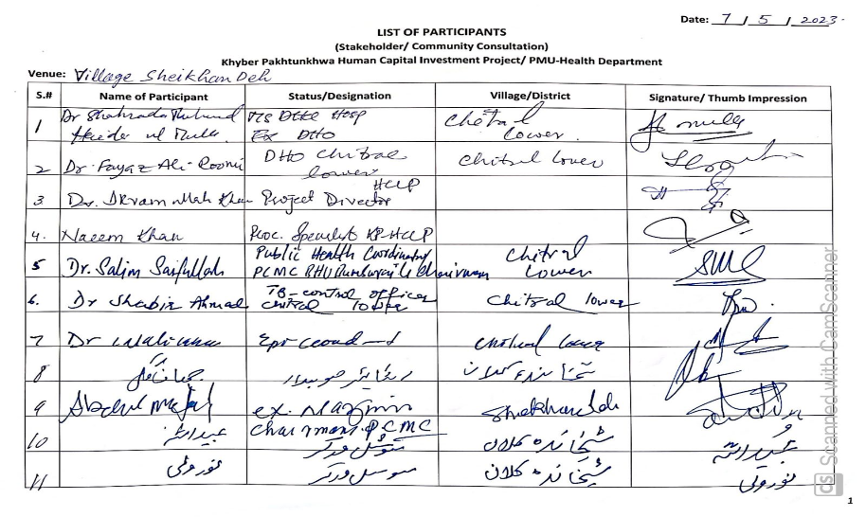

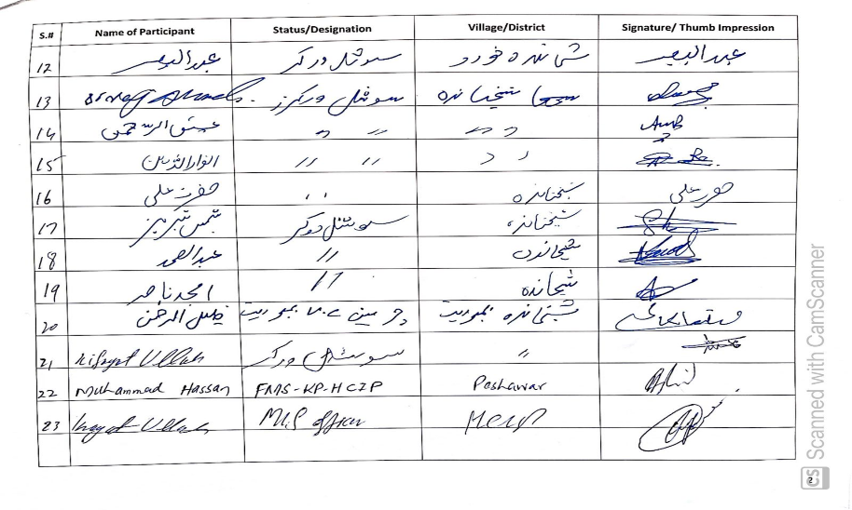

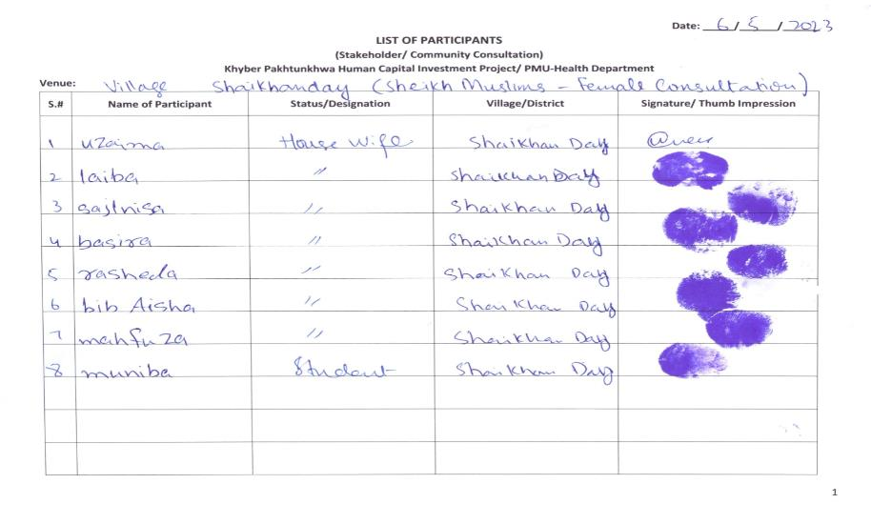

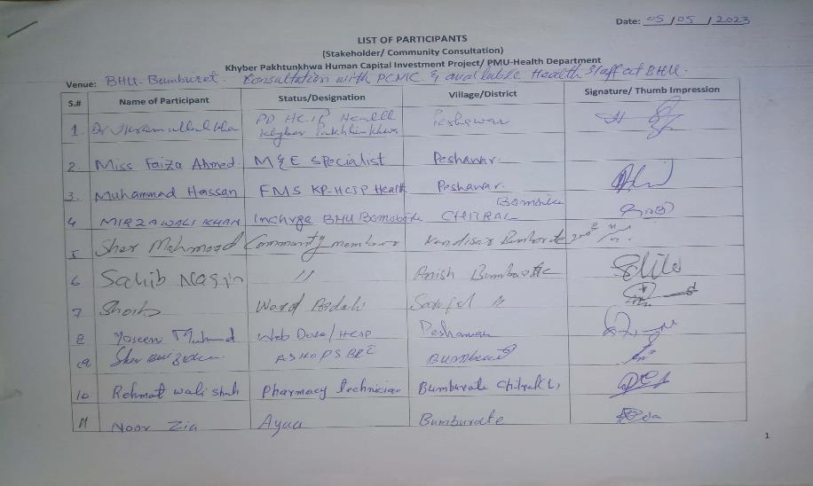

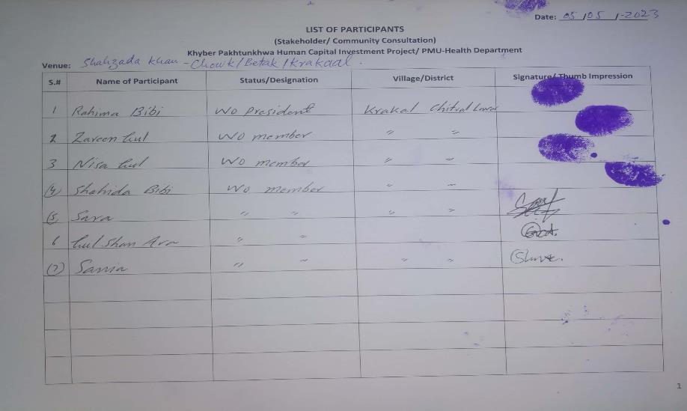

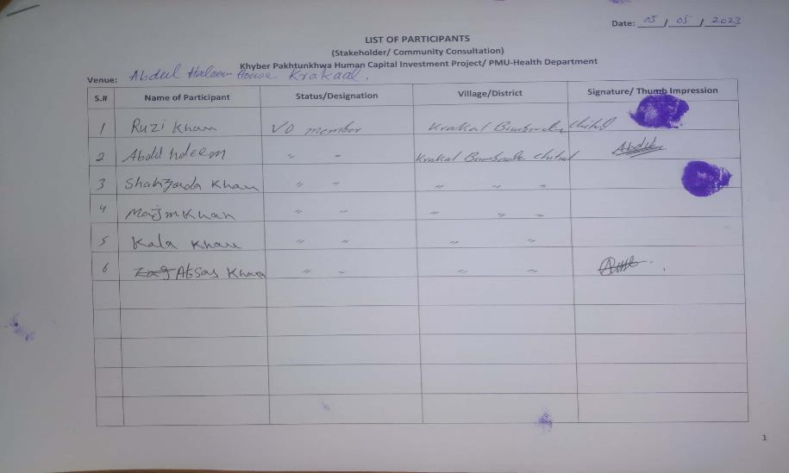

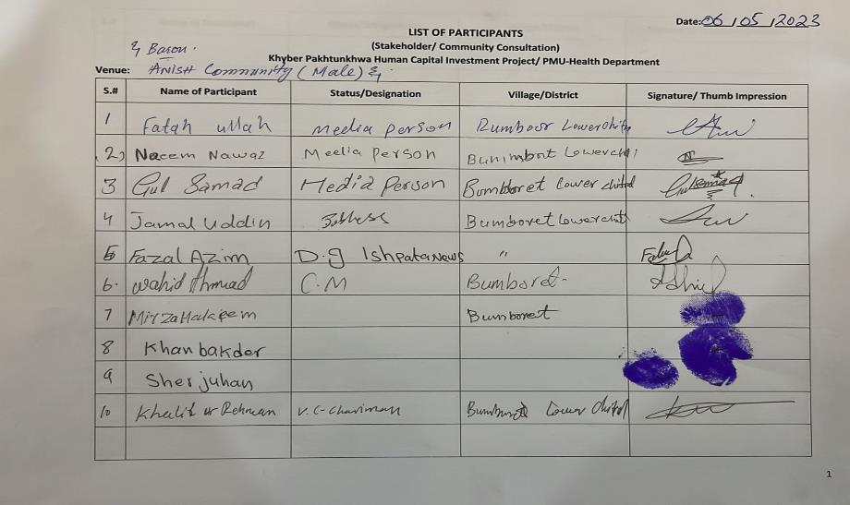

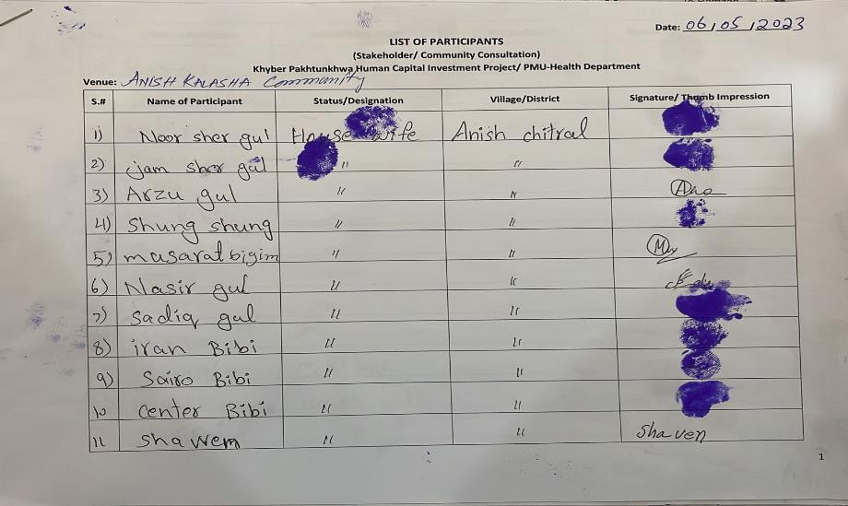

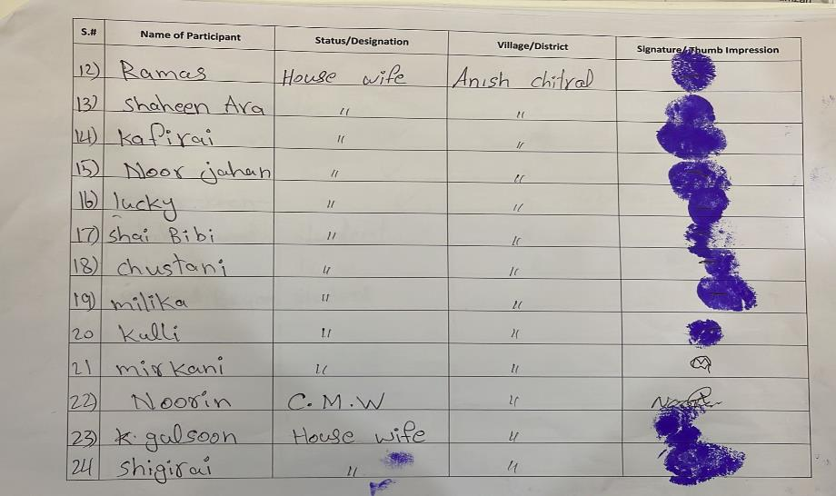

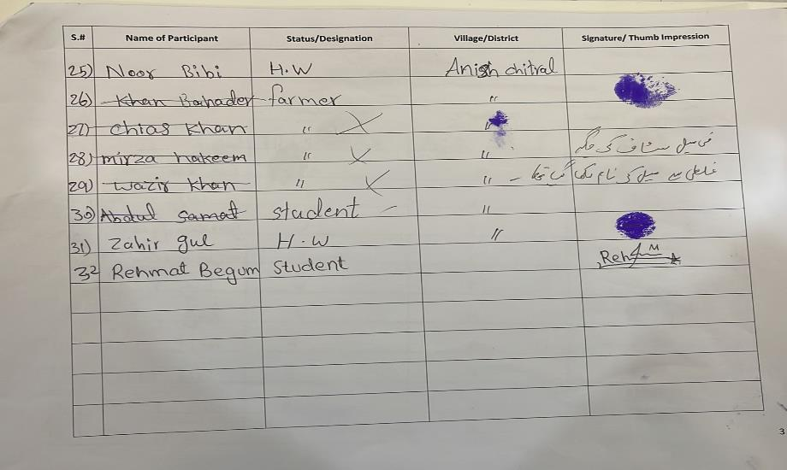

Annexure 3: Pictorial View of the Consultation Meetings/ FGDs Conducted

**Consultation Meeting/ FGD with Kalasha Community members at village Krakaal**

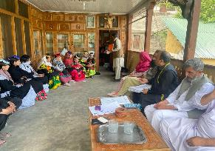

**Consultation Meeting/ FGD with PCMC members and available BHU staff (including two Kalasha LHVs**

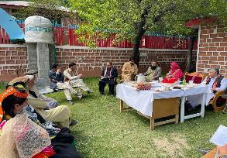

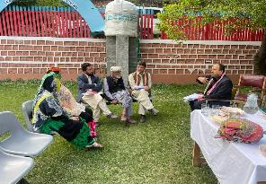

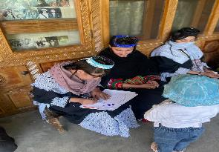

**The Kalasha participants signing the “list of participants” signifying level of education among female folk.**

**Consultation Meeting/ FGD with Muslim Sheikh Community male members**

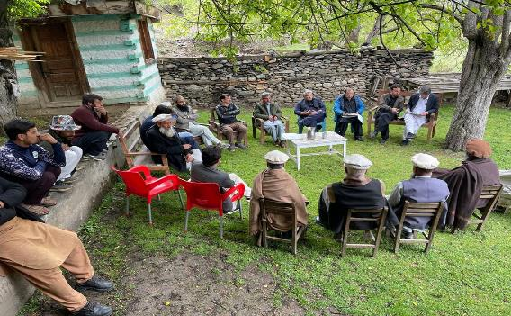

**Consultation Meeting/ FGD with Muslim Sheikh Community female members**

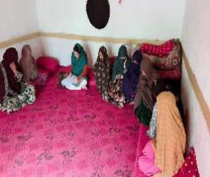

**FGD with Community female members of village Anish & Baron**

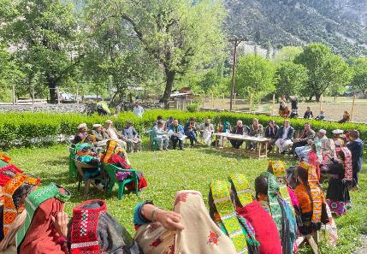

**Consultation Meeting/ FGD with Community female members of village Anish & Baron**

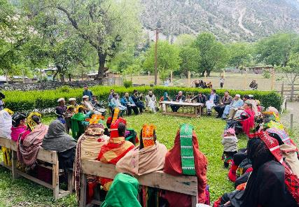

**Key Informant Interview with Chairman Village Council – Bumburet**

**Key Informant Interview with District Health Officer (DHO) Chitral Lower and MS DHQ Hospital Chitral**

**Key Informant Interview with KP - Ex-Minister for Minorities Affairs (he himself belongs to Kalasha community)**

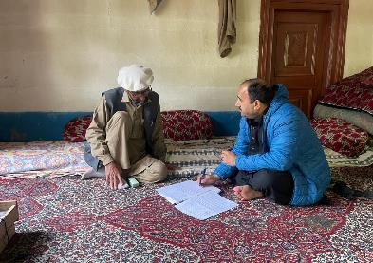

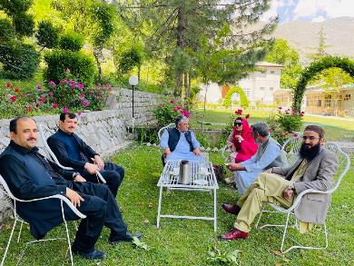

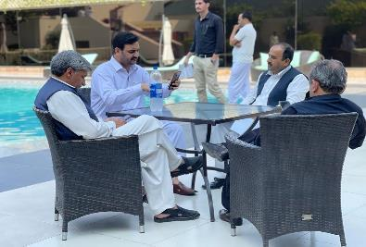

**Key Informant Interview with Chief Executive Officer (CEO) Ishpata News (Pvt), Luq Rehmat is also a Social Activist (He also belongs to Kalasha community**

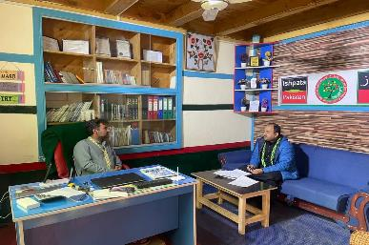

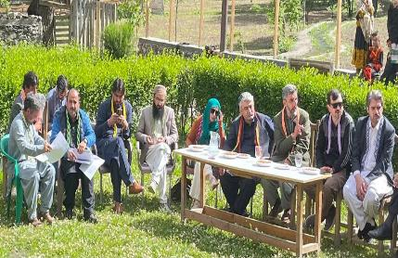

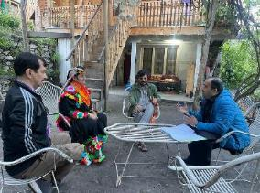

**Key Informant Interview with Local Female Social Activist Miss. Iran Bibi – Bumburet & a group picture of Heath Team**

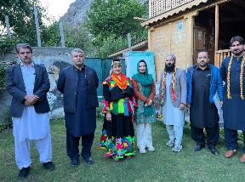

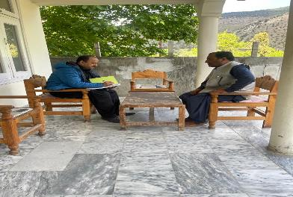

**Key Informant Interview with Officials of Tehsil Municipal Administration – Bumburet**

**Key Informant Interview with Local Female Village Councilor Miss. Shaira Bibi – Bumburet**

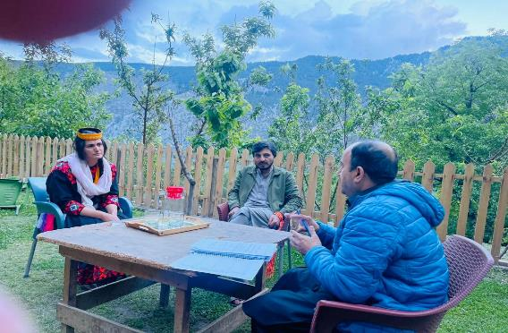

**Damages to the back wall of the BHU Bumburet**

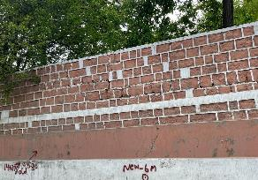

**Another view from the back side of the BHU, showing agriculture field. The apparent downstream is also the usual flood water passageway towards back wall of the healthcare facility - Bumburet.**

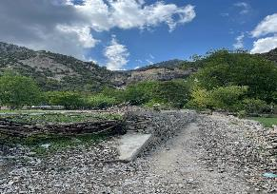

**Picture signifies the water source from upstream mountains during raining, also showing flood water usual way (from the source toward healthcare facility or leading to BHU Bumburet**

Annexure 4: Questionnaire (English Version)

Community Consultation Questionnaire

Rehabilitation of Flood Damaged Basic Health Unit – Bumburet in Kalash Valley – District Chitral

**Project Brief:** GoKP is implementing the KPHCIP with support from the World Bank to improve utilization of quality health and education services in refugee hosting districts of KP. The project development objective is to improve availability, utilization and quality of primary healthcare and elementary education services.

Due to recent flood damages in KP, the project plans to support the provincial government in rehabilitating flood damaged primary health care facilities, including BHU Bumburet.

The BHU Bumburet was partially damaged during the recent floods. According to our information the Kalasha people (community of Bumburet) mainly depend on this facility for healthcare.

**Objective of the Consultation:**

The purpose of conducting consultation meetings/ FGDs, is to (i) seek your feedback about the planned rehabilitation work, (ii) record any suggestions you may have and (ii) any concerns you may wish to put on record. In case of any anticipated adverse consequences, the project may either avoid or devise appropriate mitigation measures accordingly.

In view of the project planned activities and objective of the consultation meeting/ FGD, we are seeking your consent to participate. Do you agree to be part of this consultations i) Yes ii) No

|  |  |
| --- | --- |
| Date of Consultation/ FGD |  |
| Facilitator/ Interviewer name |  |
| Respondent(s) Name/ Community |  |
| Respondent description (position, occupation, etc) |  |
| Venue: (BHU/ village/ community, etc) |  |
| Sex: Male/Female |  |

|  |  |
| --- | --- |
| 1 | How many villages/communities depend on the BHU Bumburet for medical treatment? |
| 2 | To your knowledge, how many Kalasha peoples’ households and other communities’ households (if any) are living around this BHU? |
| 3 | How often do you or someone in your household visit the BHU Bumburet for availing medical services/ facilities in a year? |
| 4 | Have you or someone in your household ever had to travel outside Bumburet for healthcare services? If so, where to and how do you get access there? |
| 5 | What are your views on the quality of healthcare services provided by the BHU prior to its partial damage in the recent floods? |
| 6 | To what extent do you think the recent floods have impacted the provision of health services to the local communities, particularly the Kalash? |
| 7 | In your view how many Kalasha people and communities will be impacted due to rehabilitation activities in the BHU? (Probe: how and in what ways?) |
| 8 | During rehabilitation work in the BHU, to what extent do you think the resident Kalasha people will be affected in getting medical treatment or in any other aspect? (Probe: in what ways?) |
| 9 | What are the specific concerns for the community, particularly women during rehabilitation work in the BHU? (Probe: privacy, access, getting medical treatment during the work on the BHU etc.) |
| 10 | What are your concerns about any environmental and social impacts of the project particularly during rehabilitation activities? Please describe both positive and negative impacts. |
| 11 | Do you think the BHU staff and contractors who will be working on the BHU rehabilitation need to be sensitized to the cultural practices and beliefs of the local community? If so, can you suggest any measures that should be considered to safeguard local culture and norms during rehabilitation activities? |
| 12 | Are you aware of any channels to raise grievance/complaints at the BHU? If so, have you ever lodged a complaint (Probe: what was their experience, was it resolved, how long did it take) |
| 13 | Is there anything else you would like to share about the BHU’s facilities and services considering the expected rehabilitation of the BHU? (Probe: Any additional information?) |

Annexure 5: Questionnaire (Urdu Version)

**کمیونٹی کنسلٹیشن سوالنامہ**

**سیلاب سے متاثرہ شدہ بنیادی ہیلتھ یونٹ کی بحالی - کالاش ویلی – بمبوریت- ضلع چترال**

مختصراً پراجیکٹ: خیبر پختونخواہ کی حکومت پناہ گزینوں کی میزبانی کرنے والے اضلاع میں معیاری صحت اور تعلیم کی خدمات کے استعمال کو بہتر بنانے کے لیے عالمی بینک کے تعاون سے KPHCIP کو نافذ کر رہی ہے۔ پروجیکٹ کی ترقی کا مقصد بنیادی صحت کی دیکھ بھال اور ابتدائی تعلیم کی خدمات کی دستیابی، استعمال اور معیار کو بہتر بنانا ہے۔

کے پی میں حالیہ سیلاب سے ہونے والے نقصانات کی وجہ سے، پراجیکٹ کا منصوبہ ہے کہ سیلاب سے تباہ شدہ بنیادی صحت کی دیکھ بھال کی سہولیات کی بحالی میں صوبائی حکومت کی مدد کرے، بشمول BHU بمبوریٹ۔

حالیہ سیلاب کے دوران BHU بمبوریٹ کو جزوی نقصان پہنچا تھا۔ ہماری معلومات کے مطابق کالاشہ کے لوگ (بمبوریٹ کی کمیونٹی) بنیادی طور پر صحت کی دیکھ بھال کے لیے اس سہولت پر انحصار کرتے ہیں۔

**مشاورت کا مقصد:**

مشاورتی میٹنگز/FGDs کے انعقاد کا مقصد ہے (i) بحالی کے منصوبہ بند کام کے بارے میں آپ کی رائے حاصل کرنا، (ii) آپ کی کوئی بھی تجاویز ریکارڈ کرنا اور (ii) کوئی بھی تشویش جو آپ ریکارڈ پر رکھنا چاہتے ہیں۔ کسی بھی متوقع منفی نتائج کی صورت میں، پروجیکٹ یا تو اس سے بچ سکتا ہے یا اس کے مطابق مناسب تخفیف کے اقدامات وضع کر سکتا ہے۔

پراجیکٹ کی منصوبہ بند سرگرمیوں اور مشاورتی میٹنگ/FGD کے مقصد کے پیش نظر، ہم شرکت کے لیے آپ کی رضامندی کے خواہاں ہیں۔ کیا آپ اس مشاورت کا حصہ بننے سے اتفاق کرتے ہیں. i) ہاں ii) نہیں۔

|  |  |
| --- | --- |
|  | مشاورت/ FGD کی تاریخ |
|  | سہولت کار/ انٹرویو لینے والے کا نام |
|  | جواب دہندگان کا نام/کمیونٹی |
|  | جواب دہندہ کی تفصیل (مقام، پیشہ، وغیرہ) |
|  | مقام: (BHU/ گاؤں/ کمیونٹی، وغیرہ) |
|  | جنس: مرد/عورت |

|  |  |
| --- | --- |
| **سوالات** | نمبر |
| کتنے گاؤں/کمیونٹیز طبی علاج کے لیے بی ایچ یو بمبورٹ پر انحصار کرتی ہیں؟ | 1 |
| آپ کے علم کے مطابق، اس بی ایچ یو کے ارد گرد کتنے کالاشوں کے گھرانے اور دیگر کمیونٹیز کے گھرانے (اگر کوئی ہیں) رہ رہے ہیں؟ | 2 |
| آپ یا آپ کے گھر کا کوئی فرد سال میں کتنی بار طبی سہولیات حاصل کرنے کے لیے بی ایچ یو بمبوریت جاتے ہیں؟ | 3 |
| کیا آپ کو یا آپ کے گھر کے کسی فرد کو صحت کی سہولیات /خدمات حاصل کرنے کے لیے کبھی بمبریٹ سے باہر سفر کرنا پڑا ہے؟ اگر ایسا ہے تو کہاں اور کیسے جاتے ہیں؟ | 4 |
| حالیہ سیلاب میں BHU کے جزوی نقصان سے پہلے صحت کی سہولیات/ خدمات کے معیار پر آپ کے خیالات کیا ہیں؟ | 5 |
| آپ کے خیال میں حالیہ سیلاب نے مقامی آبادیوں بالخصوص کالاش کو صحت کی سہولیات /خدمات کی فراہمی کو کس حد تک متاثر کیا ہے؟ | 6 |
| آپ کے خیال میں بی ایچ یو میں بحالی کی سرگرمیوں کی وجہ سے کتنے کیلاشا لوگ اور کمیونٹیز متاثر ہوں گی؟ (تحقیق: کیسے اور کن طریقوں سے؟) | 7 |
| بی ایچ یو میں بحالی کے کام کے دوران، آپ کے خیال میں کالاشہ کے رہائشی لوگ طبی علاج یا کسی اور پہلو سے کس حد تک متاثر ہوں گے؟ (تحقیق: کن طریقوں سے؟) | 8 |
| بی ایچ یو میں بحالی کے کام کے دوران کمیونٹی، خاص طور پر خواتین کے لیے کیا مخصوص خدشات ہیں؟ (تحقیقات: پرائیویسی، رسائی، بی ایچ یو پر کام کے دوران طبی علاج کروانا وغیرہ) | 9 |
| خاص طور پر بحالی کی سرگرمیوں کے دوران پروجیکٹ کے ماحولیاتی اور سماجی اثرات کے بارے میں آپ کے خدشات کیا ہیں؟ براہ کرم مثبت اور منفی دونوں اثرات کی وضاحت کریں۔ | 10 |
| کیا آپ کو لگتا ہے کہ BHU کے عملے اور ٹھیکیداروں کو جو BHU بحالی پر کام کریں گے، مقامی کمیونٹی کے ثقافتی طریقوں اور عقائد کے بارے میں آگاہی دینے کی ضرورت ہے ؟ اگر ایسا ہے تو کیا آپ کوئی ایسے اقدامات تجویز کر سکتے ہیں جن پر بحالی کی سرگرمیوں کے دوران مقامی ثقافت اور اصولوں کے تحفظ کے لیے غور کیا جانا چاہیے؟ | 11 |
| کیا آپ بی ایچ یو میں شکایت/شکایات اٹھانے کے لیے کسی چینل سے واقف ہیں؟ اگر ایسا ہے تو کیا آپ نے کبھی شکایت درج کرائی ہے (تحقیق: ان کا تجربہ کیا تھا، کیا اسے حل کیا گیا، اس میں کتنا وقت لگا) | 12 |
| کیا آپ بی ایچ یو کی متوقع بحالی کی روشنی میں BHU کی سہولیات اور خدمات کے بارے میں کچھ اور بتانا چاہیں گے؟ (تحقیقات: کوئی اضافی معلومات؟) | 13 |

Annexure 6: Detail of Flood Affected Healthcare Facilities

|  |  |  |  |  |
| --- | --- | --- | --- | --- |
| **S.#** | **Name of Health Facility District** | **Type of Damages** | | |
| **Completely Damaged** | **Partially Damaged** | **Grand Total** |
| 1 | Abbottabad | 4 | 6 | 10 |
| 2 | Charsadda |  | 4 | 4 |
| 3 | Chitral Lower |  | 9 | 9 |
| 4 | Chitral Upper | 1 | 5 | 6 |
| 5 | D. I. Khan | 3 | 19 | 22 |
| 6 | Dir Lower |  | 7 | 7 |
| 7 | Dir Upper |  | 15 | 15 |
| 8 | Karak |  | 13 | 13 |
| 9 | Kohistan Lower | 4 | 3 | 7 |
| 10 | Kohistan Upper | 1 | 4 | 5 |
| 11 | Kolai Palas (Kohistan) |  | 3 | 3 |
| 12 | Kurram Upper |  | 1 | 1 |
| 13 | Lakki Marwat | 2 | 7 | 9 |
| 14 | Nowshera |  | 4 | 4 |
| 15 | Shangla |  | 5 | 5 |
| 16 | Swat |  | 15 | 15 |
| 17 | Tank |  | 23 | 23 |
| **Grand Total** | | **15** | **143** | **158** |